Focus Group for App Design

|  |  |  |  |
| --- | --- | --- | --- |
|  | App Design1 (Marvel) | App Design 2  ( Protoi) | App Design 3  (Photoshop) |
| Overall Design | 9 | 5 | 4 |
| User Experience | 8 | 8 | 8 |
| Ease of use | 7 | 9 | 7 |
| User ability | 8 | 9 | 8 |

App 1

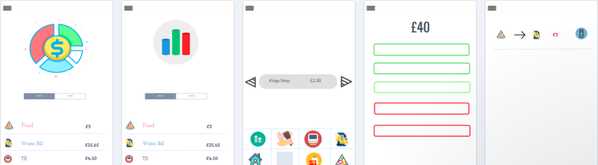

App 2

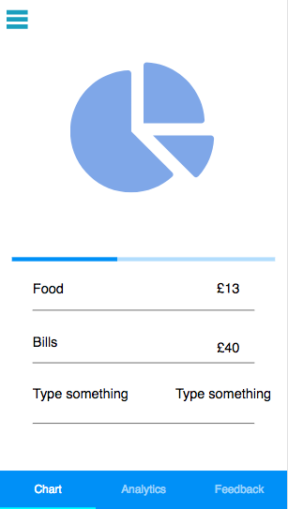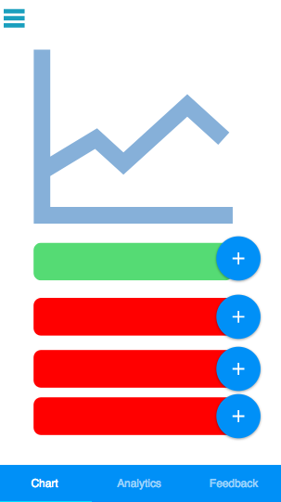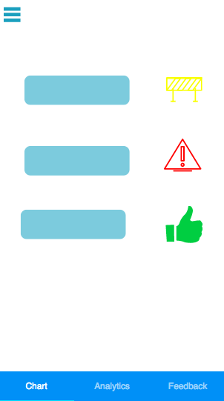

App 3

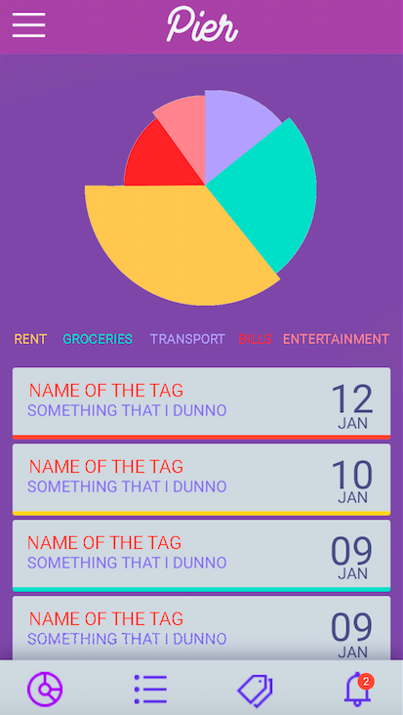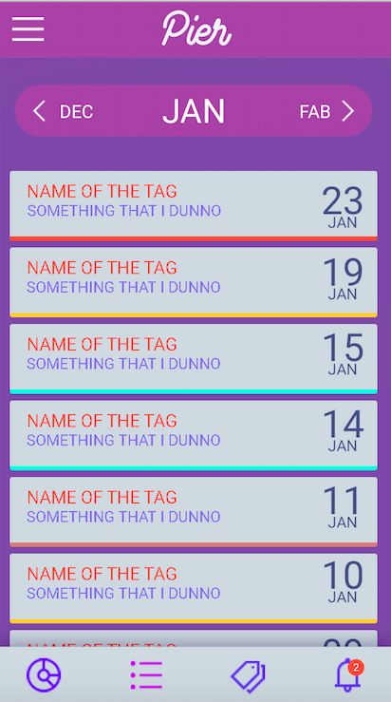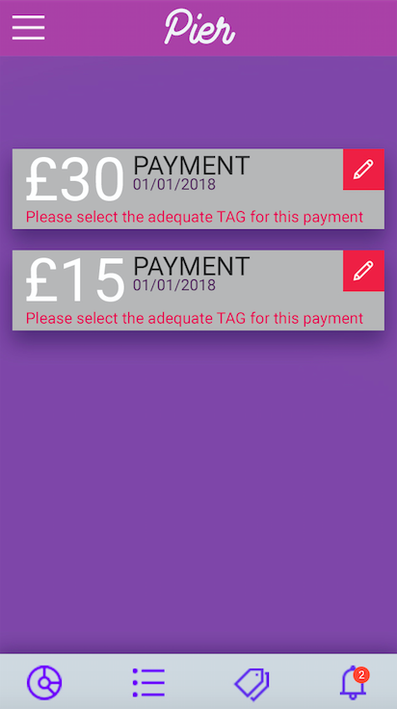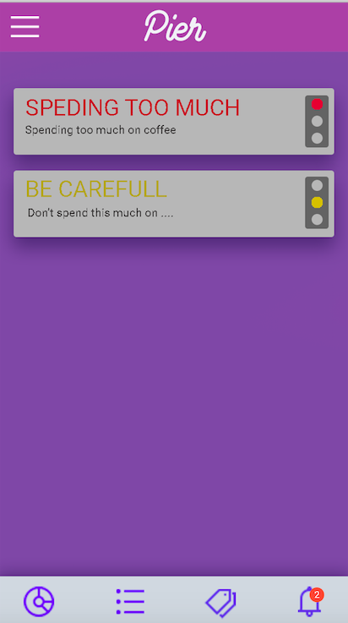

**Breakdown –**

Which App has the best breakdown?

App1 & 3

-Both are really similar

What would you change/add to make it better in your opinion?

* App 1 design with app 3 layout
* Any square boxes curve the edges to give a better look. The boxes make the app look very basic

**Data Analytics -**

Which App has the best Data Analytics?

App 1

What would you change/add to make it better in your opinion?

* App 1 has a clear cut layout
* App 2 is too cluttered

**Tags-**

Which App has the best Tags?

App 1

What would you change/add to make it better in your opinion?

- have all the other needed tags as well but in a opaque way

**Alerts**

Which App has the best Alerts?

App1

What would you change/add to make it better in your opinion?

The traffic lights is appealing

**Input Method**

Method 1 – Leave to side bar- method 1 was chosen

Method 2 – Put in tab - tab

**Any other comments/ Suggestions**